Q1#include<iostream>
#include<conio.h>
#include<stdio.h>
using namespace std;
class student
{
private:
int admno;
char sname[20];
float eng,math,science;
float total;
float ctotal()
{
return eng+math+science;
}
public:
void Takedata()
{
cout<<"Enter admission number ";
cin>> admno;
cout<<"Enter student name " ;
cin>>(sname);
cout<< "Enter marks in english, math, science ";
cin>>eng>>math>>science;
total=ctotal();
}
void Showdata()
{
cout<<"Admission number "<<admno<<"\nStudent name "<<sname<<"\nEnglish "
<<eng<<"\nMath "<<math<<"\nScience "<<science<<"\nTotal "<<total;
}
};
int main ()
{
student obj ;
obj.Takedata();
obj.Showdata();
getch();
return 0;
}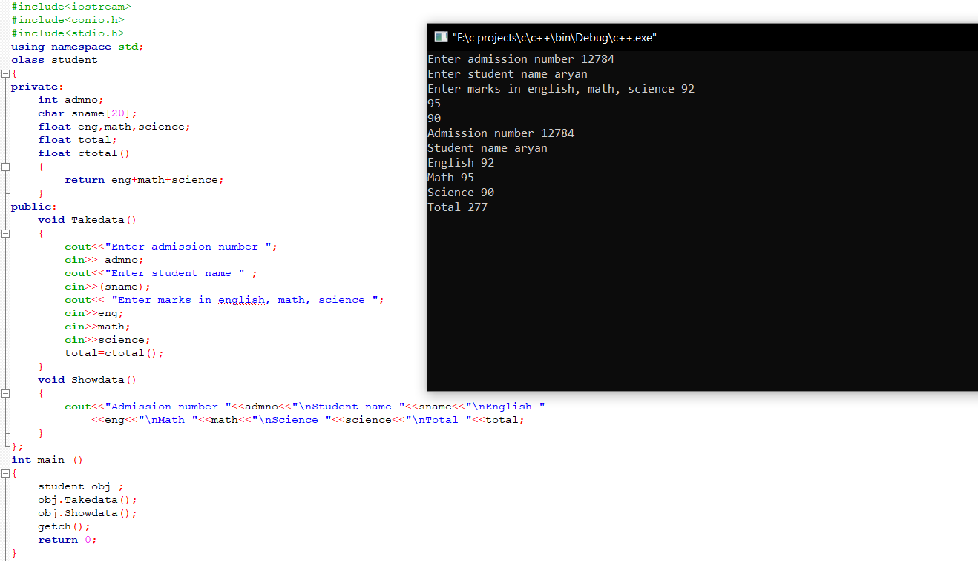
Q2#include<iostream>
#include<conio.h>
#include<stdio.h>
using namespace std;
class batsman
{
int bcode;
char bname[20];
int innings,notout,runs;
int batavg;
void calcavg()
{
batavg=runs/(innings-notout);
}
public :
void readdata ();
void displaydata();
};
void batsman::readdata ()
{
cout<<"Enter batsman code ";
cin>> bcode;
cout<<"Enter batsman name ";
cin>>(bname);
cout<<"enter innings,notout and runs ";
cin>>innings>>notout>>runs;
calcavg();
}
void batsman::displaydata()
{
cout<<"Batsman code "<<bcode<<"\nBatsman name "<<bname<<"\nInnings "<<innings
<<"\nNot out "<<notout<<"\nRuns "<<runs<<"\nBatting Average "<<batavg;
}
int main()
{
batsman obj;
obj.readdata();
obj.displaydata();
getch();
return 0;
}
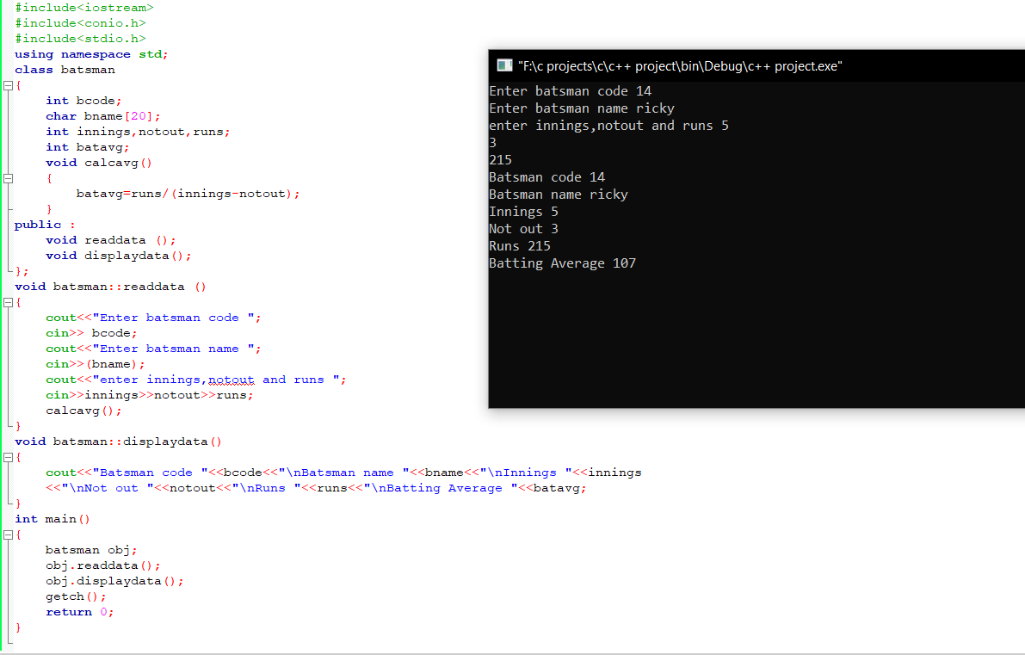
Q3
#include<iostream>
#include<conio.h>
#include<stdio.h>
using namespace std;
class TEST
{
private:
int TestCode;
char Description[30];
int NoCandidate;
int CenterReqd;
int CALCNTR()
{
return (NoCandidate/100)+1;
}
public:
void SCHDULE();
void DISPTEST();
};
void TEST::SCHDULE()
{
cout<<"Enter Test code ";
cin>> TestCode;
cout<<"Enter description ";
cin>>(Description);
cout<< "Enter no of candidates ";
cin>>NoCandidate;
CenterReqd=CALCNTR();
}
void TEST :: DISPTEST()
{
cout<<"Test code "<<TestCode<<"\nDescripton "<<Description<<"\nNo of candidate "
<<NoCandidate<<"\nCenter required "<<CenterReqd;
}
int main ()
{
TEST obj;
obj.SCHDULE();
obj.DISPTEST();
getch();
return 0;
}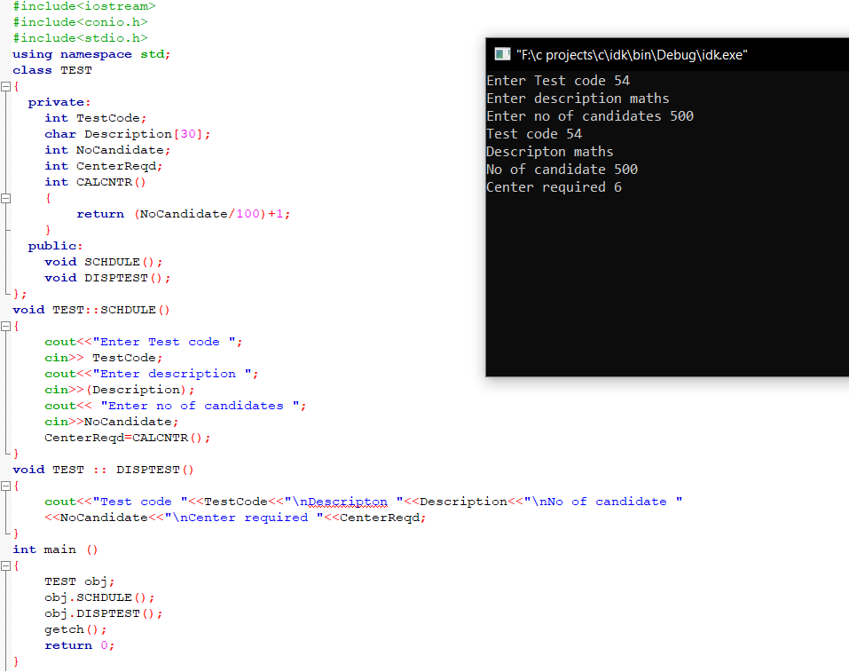
Q4
#include <iostream>
using namespace std;
class flight
{
private:

int flightnumber;
char destination[30];
float distance;
float fuel;
float calfuel()
{
if(distance<=1000)
{ fuel = 500;
}
else if(distance>1000 &&distance<=2000)
{
fuel = 1100;
}
else if(distance>2000)
{
fuel = 2200;
}
return fuel;
}

public:

void feedinfo()
{
cout<<"Enter Flight number:";
cin>>flightnumber;
cout<<"Destination:";
cin>>destination;
cout<<"distance :";
cin>>distance;
calfuel();

}

void showinfo()
{

cout<<"Flight number:"<<flightnumber<<endl;
cout<<"destination"<<destination<<endl;
cout<<"Distance : "<<distance<<endl;
cout<<"Fuel :"<<calfuel()<<endl;

}
};
int main()
{
flight obj; //object creation

obj.feedinfo();
obj.showinfo();

return 0;
}
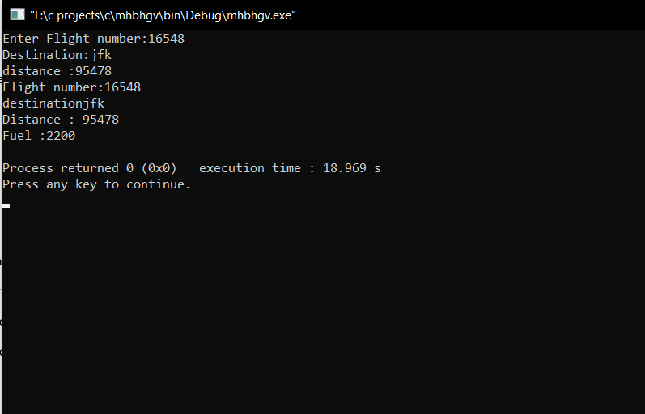
Q5#include<iostream>
#include<stdio.h>
#include<conio.h>
using namespace std;
class BOOK
{
int BOOKNO;
char BOOKTITLE[20];
float PRICE;
void TOTAL_COST(int N)
{
float tcost;
tcost=PRICE*N;
cout<<tcost;
}
public:
void INPUT()
{
cout<<"Enter Book Number ";
cin>>BOOKNO;
cout<<"Enter Book Title ";
cin>>(BOOKTITLE);
cout<<"Enter price per copy ";
cin>>PRICE;
}

void PURCHASE()
{
int n;
cout<<"Enter number of copies to purchase ";
cin>>n;
cout<<"Total cost is ";
TOTAL_COST(n);
}
};

int main()
{
BOOK obj;
obj.INPUT();
obj.PURCHASE();
getch();
return 0;
}
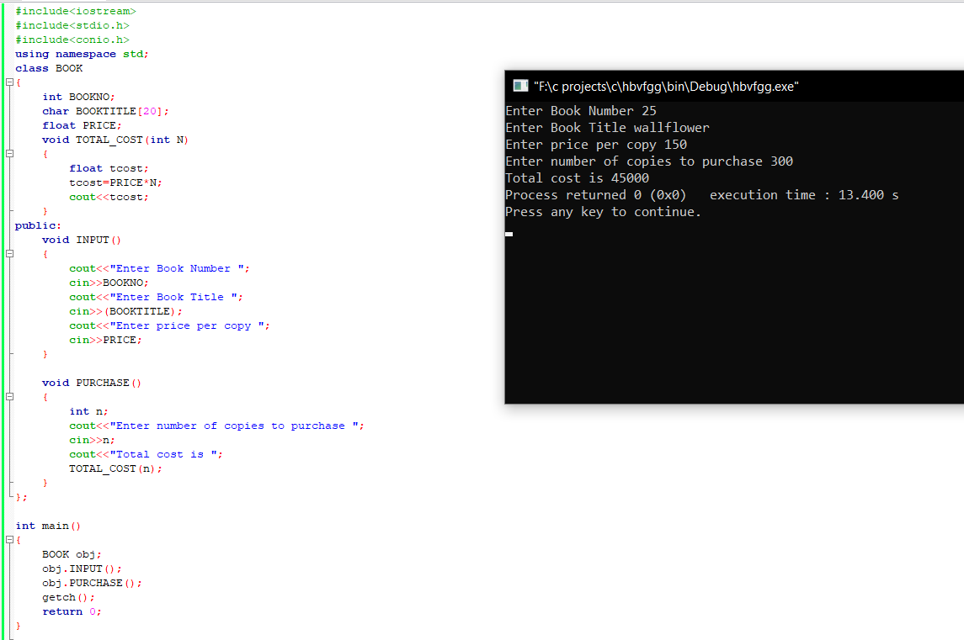
Q6#include<iostream>
#include<stdio.h>
#include<conio.h>
using namespace std;
class REPORT
{
int adno;
char name[20];
float marks[5];
float average;
void GETAVG()
{
average = (marks[0]+marks[1]+marks[2]+marks[3]+marks[4])/5;
}
public:
void READINFO();
void DISPLAYINFO();
};
void REPORT::READINFO()
{
do
{
cout<<"Enter 4 digit admission number ";
cin>>adno;
}while(adno<999 || adno>10000);
cout<<"Enter name";
cin>>(name);
cout<<"Enter marks in ";
for(int i=0;i<5;i++)
{
cout<<"Subject "<<i+1<<":";
cin>>marks[i];
};
GETAVG();
}
void REPORT::DISPLAYINFO()
{
cout<<"Admission number:"<<adno<<" Name:"<<name<<" Marks are:"<< marks[0]<<" "<< marks[1]
<<" "<<marks[2]<<" "<< marks[3]<<" "<< marks[4]<<" Average:"<<average;
}
int main()
{
REPORT obj;
obj.READINFO();
obj.DISPLAYINFO();
getch();
return 0;
}
